CS590

Big data analytics and Application

By: Vidhi Shah

Q: 1

Choose any devices (Android smartphone, SensorTag, Chronos Watch). Refer to the SensorTag UUID Info if you want to use SensorTag.

A.1

In this lab work, I have used SensoTag device.

Q:2

Implement an application to generate a file for your activities (including the following information) by modifying the existing applications (e.g., App1, App2, App3, App4, App5, FlyingMouse, SensorTag App, etc). The text file should include at least FOUR types of information on your activities (e.g., Time, GPS, Acceleration, Temperature, Humidity, Signal Frequency, Gyroscope, Pressure, etc)

The text file should include at least FOUR types of information on your activities (e.g., Time, GPS, Acceleration, Temperature, Humidity, Signal Strength, Gyroscope, Pressure, etc)

A:2

I have implemented application to get the following six different type of data in text format:

* Humidity
* Gyoscope
* Temperature
* Date
* Geolocation
* Acceleration

Q : 3

Implement an HBase Client to insert your data to HBase (either Local Cloudera or UMKC VMwares)

A:3

Using Hbase JAVA API, I succeed to push my data into HBase:

Screenshot:1 Date

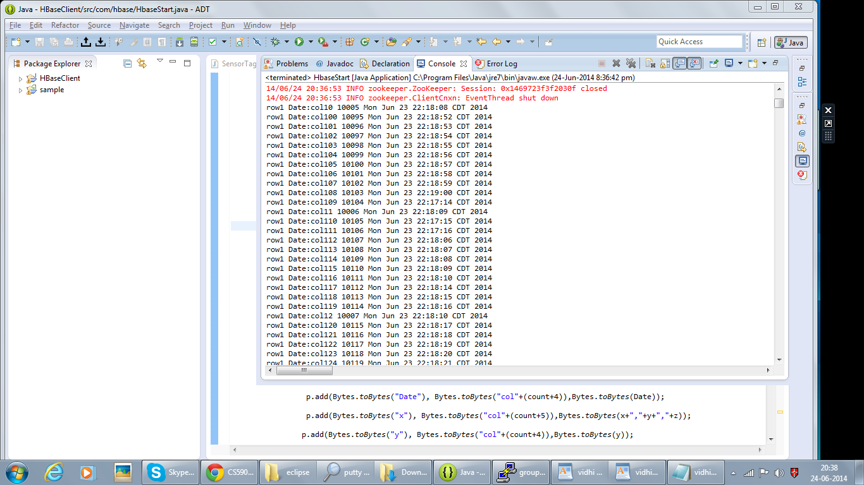

Screenshot : 2 Humidity

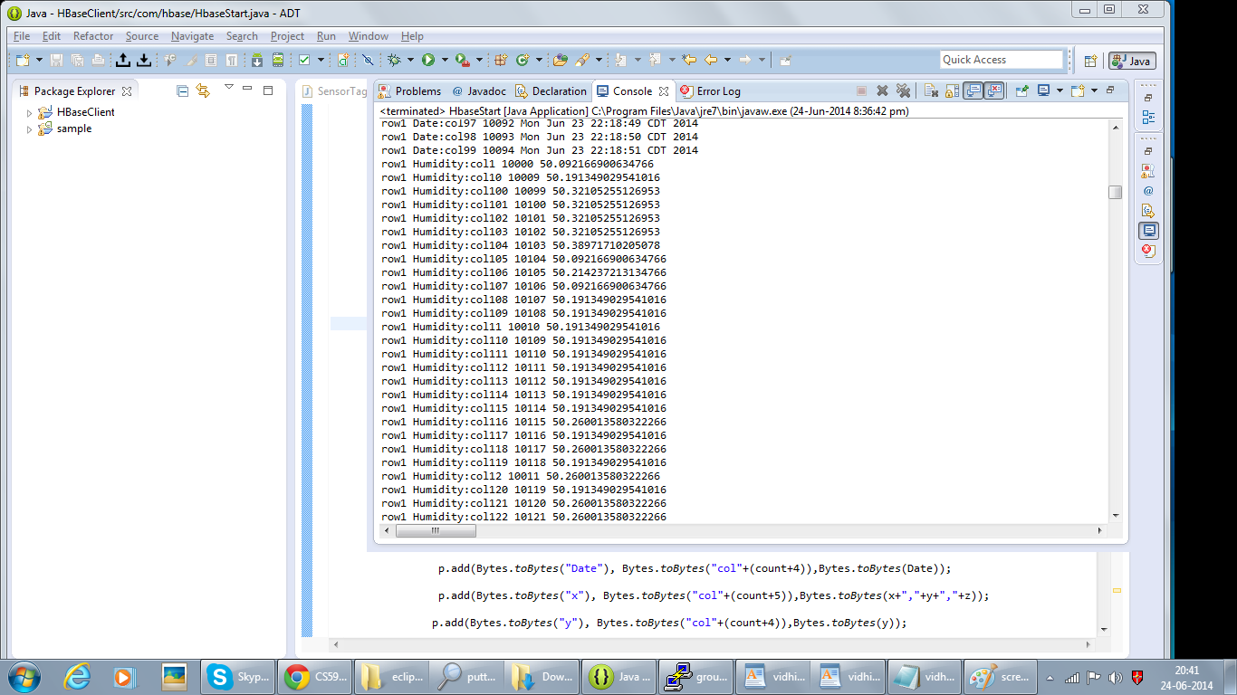

Screenshot: 3 temperature

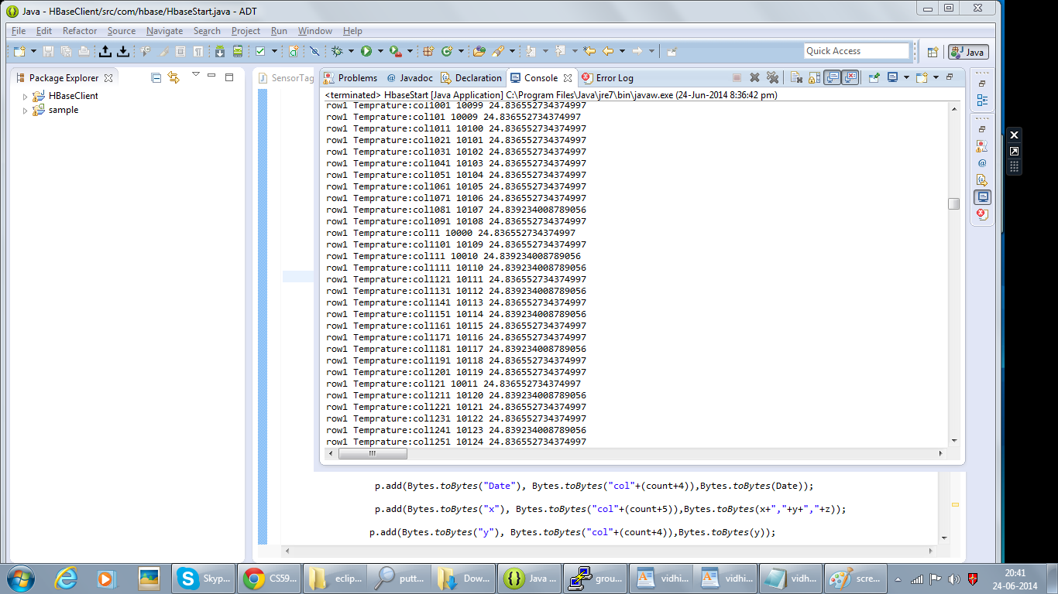

Screenshot: 4 latitude

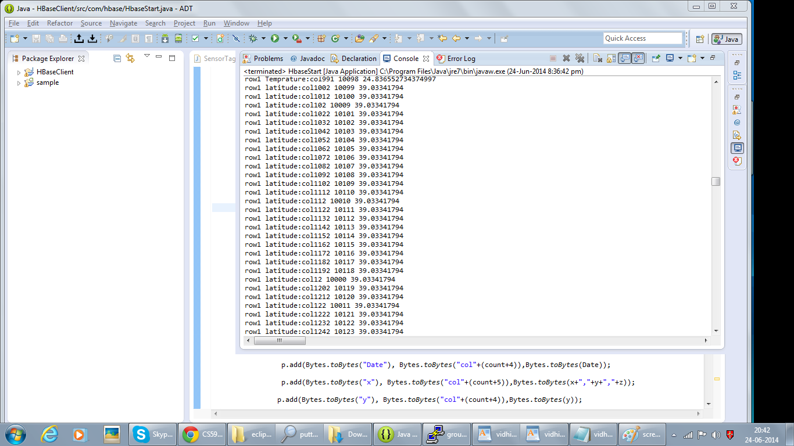

Screenshot:5 longitude

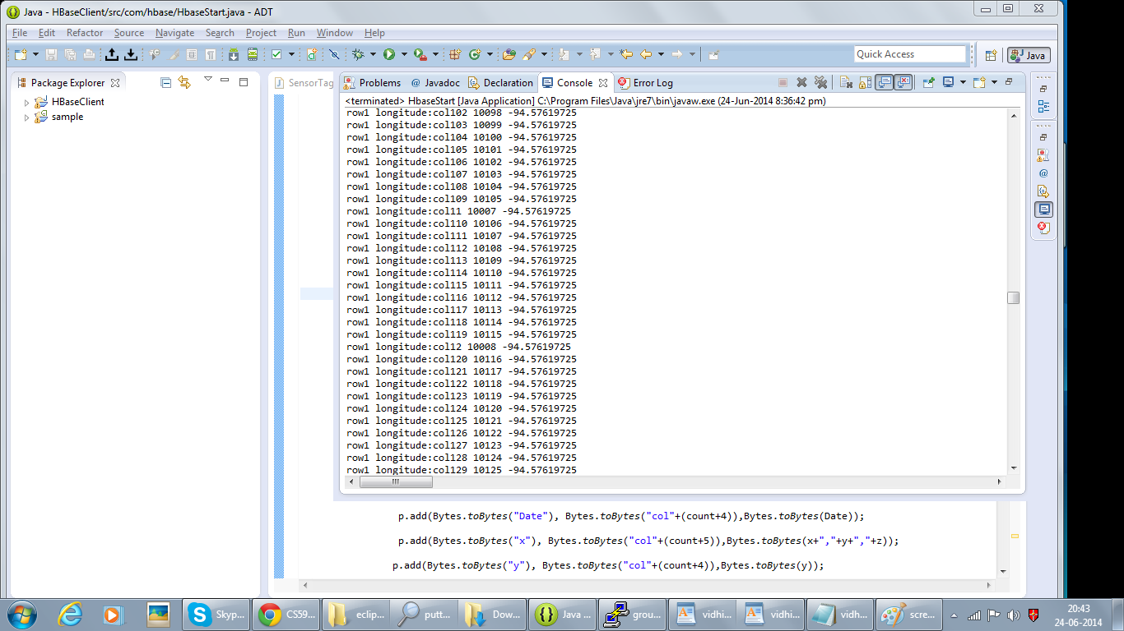

Screenshot: 6 X coordination for acceleration

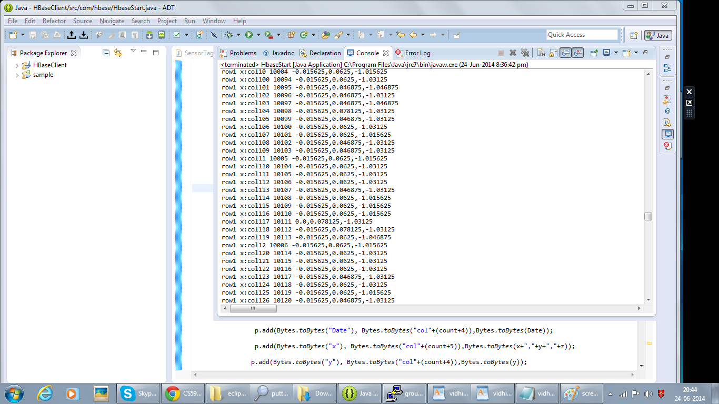

Screenshot: 7 Y coordination for acceleration

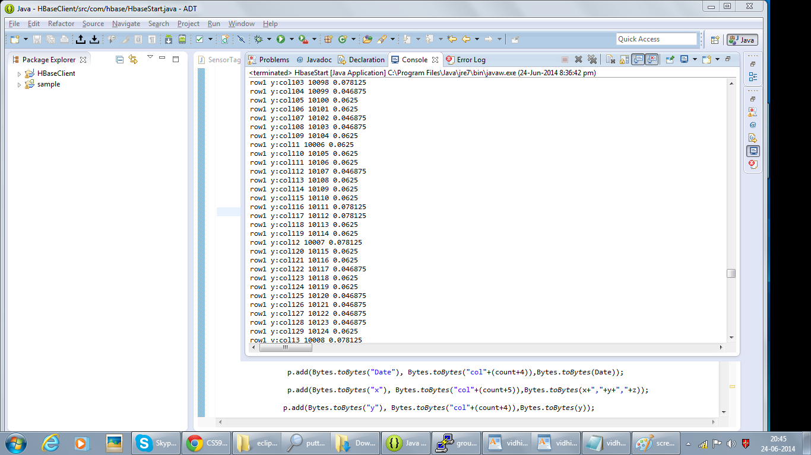

Screenshot: 8 z coordination for acceleration

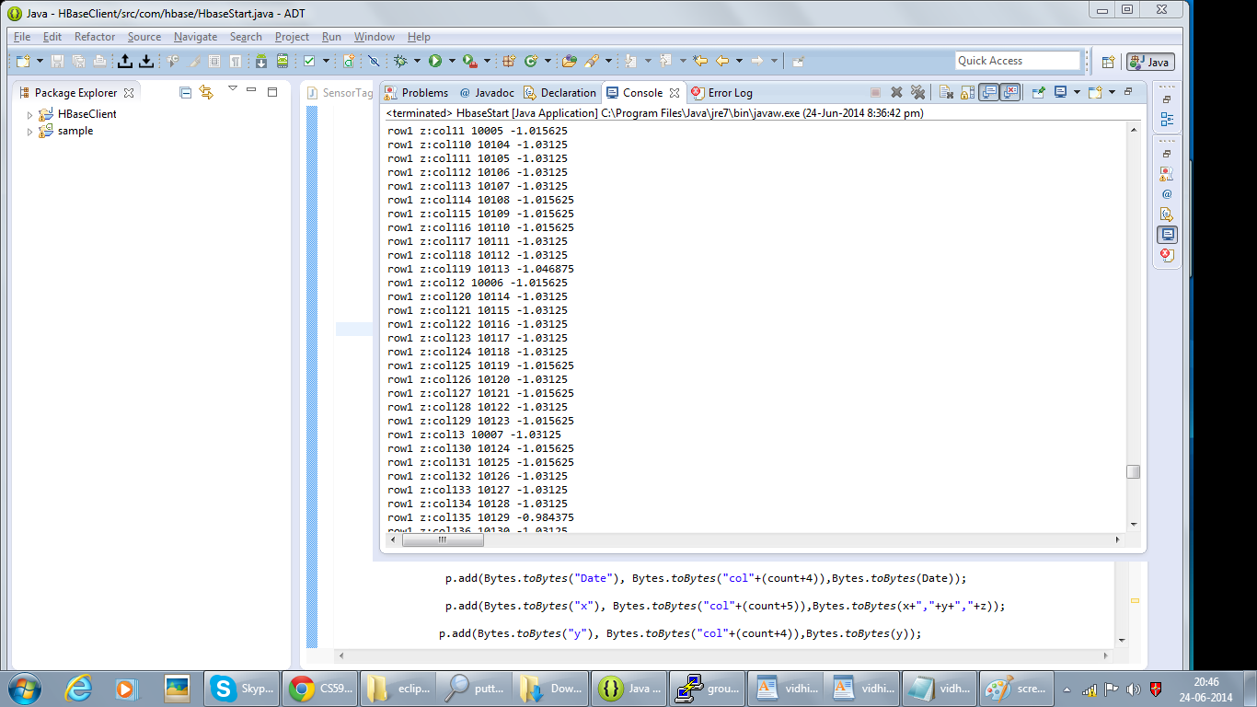

Screenshot: 9 Gyroscope

